Why Are there So Many Different Interpretations of the Bible?

The fact that some people believe that this is a great stumbling block for one’s faith is worth considering. Perhaps a brief discussion concerning metalinguistics is in order, for better understanding why there are so many evangelical Christian translations of the Bible.
Language changes slightly through time, and from culture to culture. I once had a conversation with a Rabbi while working in a Hasidic Jewish Synagogue who explained that Yiddish was always meant to be a universal language. It was as if German and Hebrew were smashed together to create a new, permanent language. The problem with this is that it did not work how it was meant to because of the nature of language changing slightly through time. Consider the King James Version, or Shakespearian English. The question could be asked, “Is this English?” of course it is, but which English, seems to be an appropriate designation. The point is, no one alive today speaks the way the King James Version reads, unless it is at a Shakespearian high school play or something of the like. This is the kind of linguistical change that people refer to when considering different biblical interpretations.
The reason that the above mentioned historical (Shakespearian) English language is no longer spoken is because language changes through time. This change in language partially explains why there are so many English translations: because modern interpreters want modern readers to understand what the original hearers understood. Modern times are always changing, therefore modern translations should change as well. Interpreters want the reader to understand what the Bible says in his or her own language.
Like Looking At a Painting

The interpretation of the New Testament from the Greek into English is a lot like looking at a painting. Everyone is looking at the same thing, but there might be some slight differences in how we interpret what we are looking at. This also helps us understand why there are so many different popular translations of the Bible in English. When a person translates from one language into another, there is never a “literal” translation. Bill Mounce, a Greek scholar and Bible translator writes, “One of the truths that I have learned since coming on the CBT is that the word, ‘literal’ should never be used in a discussion of translation because it is so readily misunderstood.” Anyone who knows more than one language understands that words cannot be exactly translated from one to the next because the idioms and culture and such are different between speakers.
When one translates from the Greek language into English (or to any other language for that matter), there is some difficulty in getting the precisely exact ideas across that the original recipients of the letter understood. Also, the words themselves often have several different definitions in Koine Greek, just like there are several different definitions in a single English word today. Think of the word, run or set. A person can run papers through a machine, can run down the road, and can see water run down the road while his car is running. Likewise, he can set something on his television set after setting his clock. The overall task of an interpreter proves to be difficult in some respects.
There is also something to be said for the ingredients of communication. There is at a basic level: a message; a giver of the message; and a receiver of such a message. When a person describes a painting then, the way that the receiver of the message (description of the painting) processes information might come to an understanding in a slightly different fashion what another receiver of the same message would come to understand. The different cultural backgrounds and different presuppositions seem to play a small part on the understanding of the one receiving the message.
Similarly, there are many interpretations because as the Koine Greek New Testament is examined, one interpreter might see an emphasis (in the text) where another interpreter might see an emphasis elsewhere (in the text). With this in mind, just like in the painting analogy, an interpreter seeks to be true to what he or she is looking at, which may have slightly varied results because the instruments used to interpret are different (i.e., people). These results have extremely little effect on what the Bible teaches as we will continue to discover.
Koine Greek once had a similar agenda as Yiddish. It was meant to be a universal language. Every country claiming a coast on the Great Sea (now, the Mediterranean) knew this trader’s language (Koine Greek), which is what the New Testament was ultimately written in, and because of such, this likely made it a second language for most people who understood it. What is interesting is that Koine Greek is arguably a phonetically lost language. If the New Testament did not exist, we have at least some reasons to believe that Koine Greek would be a completely lost language, because it is no longer spoken, much like at one time was the status of Ancient Egyptian Hieroglyphics, Ugaritic, and Runic Germanic languages.

The New Testament Has Not Changed

There are over twenty-five thousand, hand-written manuscripts of the New Testament from the old world, with about six thousand of that number being in Koine Greek. With this high number of manuscripts, they can be hypothetically (and literally) placed side by side in order to be examined. When side by side, every word can be compared to one another from manuscript to manuscript. There are slight differences in the manuscripts that are from the old world, but none of these variants, as they are called, make a difference in any of the doctrinal material that is in the New Testament. The New Testament, then, as much as it has been copied, has proof that it has not changed because we can see these documents laid out before us through the span of time, so to speak, and analyze the manuscripts from the second century forward, and because of such, we can know that it has not been changed since the original autographs with up to “99.9 percent accuracy on anything of real concern.” We can see from beginning to end, in a sense, these manuscripts which span time and see that the New Testament itself does not change through time. This is significant because we have a solid foundation to work from in translating the original language into our own modern language, namely, English, as well as that there are no doctrines in Christianity that have been altered since the beginning of Christianity. In order for Jesus to be the same yesterday, today and forever, it would also mean that His Word would have to be the same, yesterday, today and forever. Therefore our foundation, the Word of God, is infinitely strong because it does not change. It is noteworthy at this moment to point out that Jesus says in Matthew 24:35, “Heaven and earth will pass away, but my words will not pass away.” He us the ultimate authority of canonicity. The Bible is true because He is the truth (See John 14:6).
So, the differences in interpretations do not change the overall message of the Bible, at least in the most popular Evangelical Christian translations as some of them are mentioned above. Therefore, the different interpretations do not really matter all that much as long as they communicate the message of the Word of God accurately, even having minor superficial differences, and having no differences, doctrinally speaking.

The Game of Telephone Does Not Apply

It would be impossible for the Bible to change through time, because all of these thousands of manuscripts would have to be taken back from all over the world and burned, and then one would have to start over. Archaeology proves that the integrity of the Bible is second to none because we have all of these ancient manuscripts that we can place side by side and examine the texts through the corridors of time.
For more information and material, visit:
https://apologeticsandevidence.blogspot.com/

www.facebook.com/ApologeticsAndEvidence/

(Permission is granted to make copies of this pamphlet and to distribute them, provided this is done free of Charge and without altering the content.)

The Integrity of the Bible is Second to None

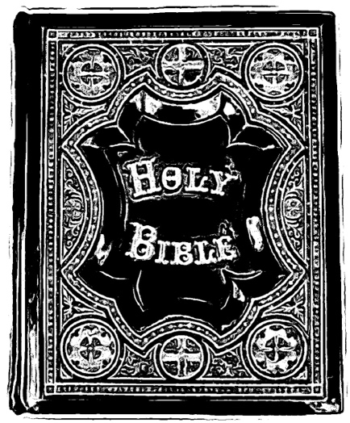

“Contend for the faith that was once
for all delivered to the saints.”
~Jude 3

@ApologeticsandEvidence

Though the object, the painting, remains the same.
William D. Mounce, What I Have learned About Greek and Translation: Since Joining the CBT (Grand Rapids: Zondervan, 2017), 7.
Norman Geisler and Joseph M. Holden. The Popular Handbook of Archaeology and the Bible (Eugene: Harvest House Publishers, 2013), 122; Craig Blomberg. The Historical Reliability of the New Testament (Nashville: B&H Academic, 2016), 613.
Norman Geisler and William L. Nix. From God to us: How we got our Bible (Chicago: Moody Publishers, 2012), 243.
Geisler and Holden, 127.
See Hebrews 13:8.

